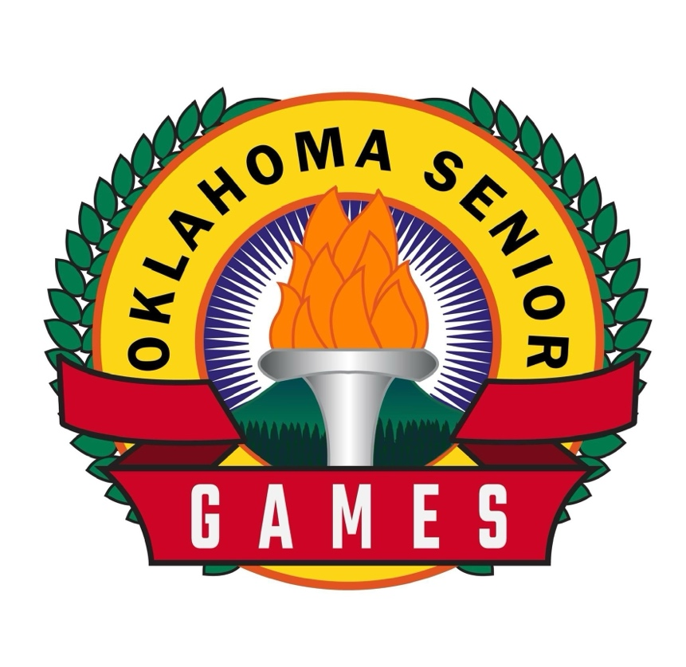

Oklahoma Senior Games Fitness Challenge
2026

Oklahoma Senior Games Fitness Challenge
OKSeniorGames.com 405-821-1500 info@OKSeniorGames.com
There are two levels for the challenge: Competitive and Novice. The athletes who are new to training may use but are not required the Novice weights and heights. Please consult your physician or make sure there are no medical conditions that would prevent you from taking the Fitness Challenge.
FITNESS CHALLENGE SUMMARY 2026
Goblet Squat Instructions
The number of CORRECTLY EXECUTED Goblet Squats performed in 1 minute touching briefly a bench 17” to 18.5” inches high carrying the prescribed weight below for age and gender. (see OSG website for video)
Push-Ups Instructions
The number of CORRECTLY EXECUTED Push-Ups performed in 1 minute men’s chest to a 4” yoga block or for women to achieve a 45 degree arm bend at the prescribed bar height for their age.
Plank Instructions
Athletes will hold a forearm plank for up to 3 minutes rewarded with points.
One Leg Balance Instructions
Athletes have 3 tries to balance on 1 leg up to 3 minutes.
Grip Strength Test
Measures grip strength using hand dynamometer.
5-10-5 Yard Shuttle Run Instructions
The shuttle run test will measure agility, anaerobic, aerobic fitness, or some combination of these.
YMCA 3-minute Step Test
This test provides a submaximal measure of cardio-respiratory or endurance fitness.
Flexibility
These tests measure flexibility in different body parts.
Back Scratch Test (shoulder flexibility)
Seated Trunk Rotation Test (trunk flexibility
Toe Touch Flexibility Test (hamstring, lower back, and hip flexibility
Weight-Bearing Lunge Test (WBLT) (ankle flexibility)

Functional Reach Test (FRT)
measures balance and stability

The Step Down Test
Measures athlete proficiency for lowering his/her body when stepping down from a curb or the like.

Oklahoma Senior Games Fitness Challenge 2026

OKSeniorGames.com 405-821-1500 info@OKSeniorGames.com
There are two levels for this part of the test: Competitive and Novice. The athletes who are new to training and 60 or over may use but are not required the Novice weights and heights.

Goblet Squat Instructions
The number of CORRECTLY EXECUTED Goblet Squats performed in 1 minute touching briefly a bench 17” to 18.5” inches high carrying the prescribed weight below for age and gender. (see OSG website for video)

Points Awarded Competitive
Age Women’s Men’s Points Earned Points Earned Points Earned
Weight Weight
50-59 | 25 lbs. | 30 lbs. | 5 points for 36+ | 3 points for 32-35 | 1 point for 28-31
60-69 | 20 lbs. | 25 lbs. | 5 points for 36+ | 3 points for 32-35 | 1 point for 28-31
70-79 | 10 lbs. | 15 lbs. | 5 points for 33-35 | 3 points for 31-32 | 1 point for 29-30
80+ | 5 lbs. | 10 lbs. | 5 points for 17-18 | 3 points for 15-16 | 1 point for 13-14

Points Awarded Novice
Age Women’s Men’s Points Earned Points Earned Points Earned
Weight. Weight
50-69 | 5 lbs. | 10 lbs. | 5 points for 36+ | 3 points for 32-35 | 1 point for 28-31
70-79 | 0 lbs. | 0 lbs. | 5 points for 36+ | 3 points for 32-35 | 1 point for 38-31
80+ | 0 lbs. | 0 lbs. | 5 points for 20+ | 3 points for 17-18 | 1 point for 15-16

Push-Ups Instructions
The number of CORRECTLY EXECUTED Push-Ups performed in 1 minute men’s chest to a 4” yoga block or for women to achieve a 45 degree arm bend at the prescribed bar height for their age.

Points Awarded Competitive
Age Women’s Men’s Points Earned Points Earned Points Earned
Bar Height Position
50-59 | 12.5” | Floor | 5 points for 23+ | 3 points for 20-22 | 1 point for 17-19
60-69 | 21” | Floor | 5 points for 23+ | 3 points for 20-22 | 1 point for 17-19
70+ | 30” | Floor | 5 points for 18+ | 3 points for 16-17 | 1 point for 14-15

Points Awarded Novice
Age Women’s Men’s Points Earned Points Earned Points Earned
Bar Height Position
50-69 | 21” | Floor | 5 points for 23+ | 3 points for 20-22 | 1 point for 17-19
70+ | 30” | Floor | 5 points for 18+ | 3 points for 16-17 | 1 point for 14-15

Plank Instructions
Athletes will hold a forearm plank for up to 3 minutes rewarded with points as below:

Points Awarded Competitive
Women and Men
Age Points Earned Points Earned Points Earned
50-59 | 5 points for 3 min. | 3 points for 2:40 min. | 1 point for 2:25 min.
60-69 | 5 points for 3 min | 3 points for 2:40 min. | 1 point for 2:25 min.
70-79 | 5 points for 2:30 min. | 3 points for 2:15 min. | 1 point for 2:00 min.
80+ | 5 points for 2:00 min. | 3 points for 1:45 min. | 1 point for 1:30 min.

Points Awarded Novice
Women and Men
Age Points Earned Points Earned Points Earned
50-69 | 5 points for 1:30 min. | 3 points for 1:00 min. | 1 point for 30 sec.
70+ | 5 points for 1:00 min. | 3 points for 30 sec | 1 point for 30 sec.

One Leg Balance Instructions
The athlete has 3 tries to balance on 1 leg for up to 3 minutes. Time starts on the first try then stops when the foot touches the floor, or the athlete loses his/her balance in any other way. Athletes may not jump around. The same procedure is followed for the 2nd and 3rd tries. The athlete’s score is the total of the balance times.
Points Awarded Competitive
Women and Men
Age Points Earned Points Earned Points Earned
ALL Age Groups | 5 points for 3 min. | 3 points for 2 min 30 sec. + | 1 point for 2 min. +

Points Awarded Novice
Women and Men
Age Points Earned Points Earned Points Earned
ALL Age Groups | 5 points for 1 min 30 sec.+ | 3 points for 1 min.+ | 1 point 30 sec.+

Grip Strength Test Instructions
The athlete holds the dynamometer in the hand to be tested at a right angle with the elbow touching the side of the body. The base of the dynamometer rests on the heel of the hand and the handle rests on the middle of the four fingers. On the signal GO the person squeezes the dynamometer with maximum strength for up to 5 minutes. No other body movement is allowed.
Test 3 times with a 30 second rest between tries. Record the best of the 3 tries

Points Awarded Competitive
Ages WOMEN Points Earned Points Earned Points Earned
50-59 | 5 points for 70.3 lbs.+ | 3 points for 50.1 - 70.2 lbs. | 1 point for 38.0 - 50.0 lbs.
60-69 | 5 points for 60.0 lbs.+ | 3 points for 44.0 - 59.9 lbs. | 1 point for 34.0 - 43.9 lbs.
70-99 | 5 points for 54.0 lbs.+ | 3 points for 42.4 - 53.9 lbs. | 1 point for 32.0 - 42.3 lbs.
Ages MEN Points Earned Points Earned Points Earned
50-59 | 5 points for 111.8 lbs.+ | 3 points for 71.0 -111.7 lbs. | 1 point for 67.7 – 70.9 lbs.
60-69 | 5 points for 105.8 lbs.+ | 3 points for 84.7 - 105.7 lbs. | 1 point for 62.2 - 84.6 lbs.
70-99 | 5 points for 77.4 lbs.+ | 3 points for 55.8 -77.3 lbs. | 1 point for 47.0 - 55.7 lbs.

Points Awarded Novice
Ages WOMEN Points Earned Points Earned Points Earned
50-59 | 5 points for 70.3 lbs.+ | 3 points for 50.1 - 70.2 lbs. | 1 point for 38.0 - 50.0 lbs.
60-69 | 5 points for 60.0 lbs.+ | 3 points for 44.0 - 59.9 lbs. | 1 point for 34.0 - 43.9 lbs.
70-99 | 5 points for 54.0 lbs.+ | 3 points for 42.4 - 53.9 lbs. | 1 point for 32.0 - 42.3 lbs.
Ages MEN Points Earned Points Earned Points Earned
50-59 | 5 points for 111.8 lbs.+ | 3 points for 71.0 -111.7 lbs. | 1 point for 67.7 – 70.9 lbs.
60-69 | 5 points for 105.8 lbs.+ | 3 points for 84.7 - 105.7 lbs. | 1 point for 62.2 - 84.6 lbs.
70-99 | 5 points for 77.4 lbs.+ | 3 points for 55.8 -77.3 lbs. | 1 point for 47.0 - 55.7 lbs.
.
5-10-5 Yard Shuttle Run Instructions
The shuttle run test will measure agility, anaerobic, aerobic fitness, or some combination of these.
The usual equipment required includes a non-slip surface, marker cones, measurement tape, and a stopwatch.
Pre-test: Explain the test procedures to the subject. Perform screening of health risks and obtain informed consent. Prepare forms. test conditions (indoor/outdoor, surface type). Measure and mark out the test area. Perform an appropriate warm-up, including running at increasing speeds and incorporating turns.
Procedure: On the signal Go, the athlete runs first to the 5-yard line marker and back, then to the 10-yard line marker and back and last to the 5-yard line marker and over the finish line. The fastest time of 2 trials is recorded. Time is recorded to the 10th of a second.

Point Award Competitive
WOMEN
Ages Points Earned Points Earned Points Earned
50-59 | 5 points for 7.5 sec. | 3 points for 8.0 sec. | 1 point for 8.5 sec.
60-69 | 5 points for 8.0 sec. | 3 points for 8.5 sec. | 1 point for 9.0 sec.
70-99 | 5 points for 8.5 sec | 3 points for 9.0 sec. | 1 point for 9.5 sec.
MEN
Age Points Earned Points Earned Points Earned
50-59 | 5 points for 7.0 sec. | 3 points for 7.5 sec. | 1 point for 8.0 sec.
60-69 | 5 points for 7.5 sec. | 3 points for 8.0 sec. | 1 point for 8.5 sec.
70-99 | 5 points for 8.0 sec. | 3 points for 8.5 sec. | 1 point for 9.0 sec

Point Award Novice (5-10-5 Shuttle run continued)
WOMEN
Ages Points Earned Points Earned Points Earned
50-69 | 5 points for 9.0 sec. | 3 points for 9.5 sec. | 1 point for 10.0 sec.
70-99 | 5 points for 9.5 sec | 3 points for 10.0 sec. | 1 point for 10.5 sec.
MEN
Age Points Earned Points Earned Points Earned
50-69 | 5 points for 8.5 sec. | 3 points for 9.0 sec. | 1 point for 9.5 sec.
70-99 | 5 points for 9.0 sec. | 3 points for 9.5 sec. | 1 point for 10.0 sec

The YMCA 3-minute Step Test
This step test provides a submaximal measure of endurance fitness. The test measures heart rate recovery after three minutes of stepping.
Equipment needed: 12” step (50-69); 6” step (70+); a stop watch that records seconds; a metronome or metronome app.
Points are based upon and awarded on the resting heart rate after 3 minutes of stepping and an IMMEDIATE 60-second seated rest.
The Test: Face the step; listen to the cadence; when ready begin the 3 minutes of timed stepping: up, up, down, down.
After 3 minutes of stepping, sit down immediately and Take your pulse for 60 seconds. This can be taken at either your wrist or neck.
Special instructions: Do NOT take your pulse for 15 seconds and multiply by 4. Avoid favoring one side of your body. You can try a tap-step which allows you to switch the lead leg while keeping up with the cadence. Make sure you can find your pulse prior to starting the test.

Points Awarded Competitive
Age 46-55 56-65 65+
Excellent | 5 points | 56-82 | 60-77 | 59-81
Good | 5 points | 87-93 | 86-94 | 87-92
Above Average | 3 points | 95-101 | 97-100 | 94-102
Average | 3 points | 103-111 | 103-111 | 104-110
Below Average | 1 point | 113-119 | 111-117 | 114-118
Poor | 1 point | 121-126 | 119-128 | 121-126
Very Poor |  | 131-157 | 131-154 | 130-151

Points Awarded Novice
Age 46-55 56-65 65+
Excellent | 5 points | 56-82 | 60-77 | 59-81
Good | 5 points | 87-93 | 86-94 | 87-92
Above Average | 3 points | 95-101 | 97-100 | 94-102
Average | 3 points | 103-111 | 103-111 | 104-110
Below Average | 1 point | 113-119 | 111-117 | 114-118
Poor | 1 point | 121-126 | 119-128 | 121-126
Very Poor |  | 131-157 | 131-154 | 130-151

FLEXIBILITY
Point Award Same for Competitive and Novice
One point awarded if score is in the mean range on each of the following tests

1.Back Scratch Test (Shoulder Flexibility)
This test measures upper body flexibility by having participants reach one hand over the shoulder and the other behind the back, trying to touch their fingers. The score is measured in inches/cm (positive if fingers overlap, zero if they just touch, negative if they don't meet).
Norms for Adults 50+ (in inches)

Age Men (Mean) Women (Mean)
50-59 | -0.8 to -1.4 | 0.5 to -0.2
60-69 | -1.5 to-2.2 | 0.2 to -0.7
70-79 | -2.4 to -3.0 | -0.4 to -1.0
80+ | -3.2 to -3.8 | -1.0 to -1.8

Positive values (fingers overlapping) indicate excellent flexibility.
Negative values indicate a gap between the fingers, with larger negative numbers representing reduced flexibility.

2. Seated Trunk Rotation Test
This test measures how far you can rotate your upper body while seated. It assesses spinal mobility.
Procedure:
- Sit on a chair with feet flat on the floor, back straight, and arms crossed over a dowel stick, golf club or the link.
- Rotate the torso as far as possible to one side without moving the hips.
- Hold the position.
- The measure is the distance from the shoulder to a fixed point (e.g., a wall or measuring stick behind the person).
- Repeat on the other side.

Norms for Trunk Rotation Test (in degrees)
Age Group | Men (Mean) | Women (Mean)
50-59 | 45-50° | 45-50°
60-69 | 40-45° | 40-45°
70-79 | 35-40° | 35-40°
80+ | 30-35° | 30-35°

Higher values indicate better flexibility.
Lower values may suggest stiffness in the spine, shoulders, or core muscles.

3. Toe Touch Flexibility Test (hamstring, lower back, and hip flexibility)
Description:
The Toe Touch Test is an assessment of hamstring, lower back, and hip flexibility. It helps evaluate an individual’s ability to bend forward at the hips while keeping the legs straight, which is important for mobility, posture, and injury prevention.
Procedure:
- Stand upright with feet together and knees straight.
- Slowly bend forward at the hips, reaching down toward the toes. Keep the movement controlled without bouncing.
- The final position is measured based on how far the fingertips reach in relation to the feet:
1 Point if Fingers extend in the Mean below.
0 Points if fingertips do not fall in the Mean below.

Norms for Adults 50+ (in inches)
Age Group | Men (Mean) | Women (Mean)
50-59 | -2 to +2 | 0 to +4
60-69 | -4 to 0 | -2 to +2
70-79 | -6 to -2 | -4 to 0
80+ | -8 to -4 | -6 to -2

4.Weight-Bearing Lunge Test (WBLT) (measures ankle flexion)
Purpose: Measures ankle dorsiflexion range of motion (ROM).
Procedure:
- Stand facing a wall with one foot forward and the other slightly behind. Keep the heel of the front foot flat on the ground and bend the knee toward the wall.
- Move the foot back until the knee barely touches the wall without lifting the heel.
- Measure the distance from the toe to the wall or use a goniometer to measure the angle.
Norms:
10-12 cm (4-5 inches) from toe to wall is considered normal. 1 Point
Less than 8 cm (3 inches) may indicate limited dorsiflexion. 0 Points

5.Functional Reach Test (FRT) measures balance and stability by assessing how far an individual can reach forward while maintaining a fixed base of support. This is a useful test for fall risk.

Norms for Functional Reach Test (in inches)
Age Group | Mean Reach Distance (inches) = 1 point
50-59 | 13.5 - 14.0
60-69 | 12.5 - 13.0
70-79 | 10.5 - 11.5
80+ | 8.5 - 10.5
Interpreting the Scores
Greater than 10 inches → Low fall risk
6-10 inches → Moderate fall risk
Less than 6 inches → High fall risk

6.The Step Down Test
This test measured athlete proficiency for lowering his/her body when stepping down curbs and off other elevated surfaces. The award is 1 point or 0 points for scoring. The athlete performs this test immediately after completing the 1-minute pulse count after the 3-minute step test. This is when his/her legs are tired. The height is the same as it was for the 3-minute step test 12” for those 69 and under and 6” for athletes 70+.

The athlete steps up on the 12” or 6” platform and steps down on the other side, walks around and steps up then lowers again. The athlete lowers his/her body 3 times on each leg with control. There is no pace or speed measure to this test, only control. A touch bar must be available for the athlete to use to steady him or herself for safety. If it is used, no points are awarded. This test is failed if the athlete plops (loses control) or uses touch bar while lowering to the ground, even once.

Medals are awarded when the points for all events are added together.

Gold medal level between 33-41 total points
Silver medal level between 25-32 total points
Bronze medal level between 17-24 total points

Questions about or suggestions for the Oklahoma Senior Games Fitness Challenge contact:
Kathleen Fitzgerald kathleen.fitzgerald@OKSeniorGames.com 727.776.1877

